Lican@LAPTOP-EMVR0OKR MINGW64 ~/Desktop

$ mkdir DH

Lican@LAPTOP-EMVR0OKR MINGW64 ~/Desktop

$ mkdir DH/Peliculas

Lican@LAPTOP-EMVR0OKR MINGW64 ~/Desktop

$ mkdir DH/Peliculas/Infantiles DH/Peliculas/Accion

Lican@LAPTOP-EMVR0OKR MINGW64 ~/Desktop

$ mkdir DH/Peliculas/Comedia DH/Peliculas/Terror DH/Peliculas/Romanticas

Lican@LAPTOP-EMVR0OKR MINGW64 ~/Desktop

$ cd DH/

Lican@LAPTOP-EMVR0OKR MINGW64 ~/Desktop/DH

$ ls

Peliculas/

Lican@LAPTOP-EMVR0OKR MINGW64 ~/Desktop/DH

$ cd Peliculas/

Lican@LAPTOP-EMVR0OKR MINGW64 ~/Desktop/DH/Peliculas

$ ls

Accion/ Comedia/ Infantiles/ Romanticas/ Terror/

Lican@LAPTOP-EMVR0OKR MINGW64 ~/Desktop/DH/Peliculas

$ cd Infantiles/

Lican@LAPTOP-EMVR0OKR MINGW64 ~/Desktop/DH/Peliculas/Infantiles

$ touch Intenzamente.txt "El juego del miedo.xls" "Rapido y furioso.pdf" "Titanic.jpg"

Lican@LAPTOP-EMVR0OKR MINGW64 ~/Desktop/DH/Peliculas/Infantiles

$ ls

'El juego del miedo.xls' Intenzamente.txt 'Rapido y furioso.pdf' Titanic.jpg

Lican@LAPTOP-EMVR0OKR MINGW64 ~/Desktop/DH/Peliculas/Infantiles

$ cd ..

Lican@LAPTOP-EMVR0OKR MINGW64 ~/Desktop/DH/Peliculas

$ cd Accion/

Lican@LAPTOP-EMVR0OKR MINGW64 ~/Desktop/DH/Peliculas/Accion

$ touch "Smooth criminal.txt" "Diario de una pasion.js" "El hexorcista.xls" "Cars.jpg"

Lican@LAPTOP-EMVR0OKR MINGW64 ~/Desktop/DH/Peliculas/Accion

$ ls

Cars.jpg 'Diario de una pasion.js' 'El hexorcista.xls' 'Smooth criminal.txt'

Lican@LAPTOP-EMVR0OKR MINGW64 ~/Desktop/DH/Peliculas/Accion

$ cd ..

Lican@LAPTOP-EMVR0OKR MINGW64 ~/Desktop/DH/Peliculas

$ cd Terror/

Lican@LAPTOP-EMVR0OKR MINGW64 ~/Desktop/DH/Peliculas/Terror

$ touch "La dama y el bagavundo.png" "Yo antes de ti.xls" "Que paso ayer.pdf" "We will rock you.js"

Lican@LAPTOP-EMVR0OKR MINGW64 ~/Desktop/DH/Peliculas/Terror

$ cd ..

Lican@LAPTOP-EMVR0OKR MINGW64 ~/Desktop/DH/Peliculas

$ cd Comedia/

Lican@LAPTOP-EMVR0OKR MINGW64 ~/Desktop/DH/Peliculas/Comedia

$ touch "Madagaskar.js" "Orgullo y Prejuicio.txt" "IT.xls" "Mision Imposible.png"

Lican@LAPTOP-EMVR0OKR MINGW64 ~/Desktop/DH/Peliculas/Comedia

$ cd ..

Lican@LAPTOP-EMVR0OKR MINGW64 ~/Desktop/DH/Peliculas

$

Lican@LAPTOP-EMVR0OKR MINGW64 ~/Desktop/DH/Peliculas

$ cd Romanticas/

Lican@LAPTOP-EMVR0OKR MINGW64 ~/Desktop/DH/Peliculas/Romanticas

$ touch "Pocahontas.jpg" "Annabelle.js" "Los vengadores.js" "La mascara.js"

Lican@LAPTOP-EMVR0OKR MINGW64 ~/Desktop/DH/Peliculas/Romanticas

$ cd ..

Lican@LAPTOP-EMVR0OKR MINGW64 ~/Desktop/DH/Peliculas

$ ls -R

.:

Accion/ Comedia/ Infantiles/ Romanticas/ Terror/

./Accion:

Cars.jpg 'Diario de una pasion.js' 'El hexorcista.xls' 'Smooth criminal.txt'

./Comedia:

IT.xls Madagaskar.js 'Mision Imposible.png' 'Orgullo y Prejuicio.txt'

./Infantiles:

'El juego del miedo.xls' Intenzamente.txt 'Rapido y furioso.pdf' Titanic.jpg

./Romanticas:

Annabelle.js 'La mascara.js' 'Los vengadores.js' Pocahontas.jpg

./Terror:

'La dama y el bagavundo.png' 'Que paso ayer.pdf' 'We will rock you.js' 'Yo antes de ti.xls'

Punto 9:

* “SI”

Lican@LAPTOP-EMVR0OKR MINGW64 ~/Desktop

$ mkdir DH/Peliculas/Comedia DH/Peliculas/Terror DH/Peliculas/Romanticas DH/Peliculas/Infantiles DH/Peliculas/Accion

* “SI”

Lican@LAPTOP-EMVR0OKR MINGW64 ~/Desktop/DH/Peliculas/Infantiles

$ touch Intenzamente.txt "El juego del miedo.xls" "Rapido y furioso.pdf" "Titanic.jpg"

Lican@LAPTOP-EMVR0OKR MINGW64 ~/Desktop/DH

$ mkdir Peliculas/Romanticas/Prueba

Lican@LAPTOP-EMVR0OKR MINGW64 ~/Desktop/DH/Peliculas/Romanticas

$ mkdir ../Accion/Prueba2

VSCODE

2)

Lican@LAPTOP-EMVR0OKR MINGW64 ~/Desktop/DH

$ cd Peliculas/

Lican@LAPTOP-EMVR0OKR MINGW64 ~/Desktop/DH/Peliculas

$ cd Accion/

Lican@LAPTOP-EMVR0OKR MINGW64 ~/Desktop/DH/Peliculas/Accion

$ mv Cars.jpg ../Comedia/

Lican@LAPTOP-EMVR0OKR MINGW64 ~/Desktop/DH/Peliculas/Accion

$ mv Cars.jpg ../Infantiles/

mv: cannot stat 'Cars.jpg': No such file or directory

Lican@LAPTOP-EMVR0OKR MINGW64 ~/Desktop/DH/Peliculas/Accion

$ mv Diario\ de\ una\ pasion.js ../Romanticas/

Lican@LAPTOP-EMVR0OKR MINGW64 ~/Desktop/DH/Peliculas/Accion

$ mv El\ hexorcista.xls ../Terror/

Lican@LAPTOP-EMVR0OKR MINGW64 ~/Desktop/DH/Peliculas/Accion

$ ..

bash: ..: command not found

Lican@LAPTOP-EMVR0OKR MINGW64 ~/Desktop/DH/Peliculas/Accion

$ cd ..

Lican@LAPTOP-EMVR0OKR MINGW64 ~/Desktop/DH/Peliculas

$ cd Comedia/

Lican@LAPTOP-EMVR0OKR MINGW64 ~/Desktop/DH/Peliculas/Comedia

$ mv Cars.jpg ../Infantiles/

Lican@LAPTOP-EMVR0OKR MINGW64 ~/Desktop/DH/Peliculas/Comedia

$ mv IT.xls ../Terror/

Lican@LAPTOP-EMVR0OKR MINGW64 ~/Desktop/DH/Peliculas/Comedia

$ mv Madagaskar.js Desktop/DH/Peliculas/Infantiles

mv: cannot move 'Madagaskar.js' to 'Desktop/DH/Peliculas/Infantiles': No such file or directory

Lican@LAPTOP-EMVR0OKR MINGW64 ~/Desktop/DH/Peliculas/Comedia

$ mv Madagaskar.js c:Desktop/DH/Peliculas/Infantiles

mv: cannot move 'Madagaskar.js' to 'c:Desktop/DH/Peliculas/Infantiles': No such file or directory

Lican@LAPTOP-EMVR0OKR MINGW64 ~/Desktop/DH/Peliculas/Comedia

$ mv Madagaskar.js C:/Users/Lican/Desktop/DH/Peliculas/Infantiles

Lican@LAPTOP-EMVR0OKR MINGW64 ~/Desktop/DH/Peliculas/Comedia

$ mv Mision\ Imposible.png ../Accion/

Lican@LAPTOP-EMVR0OKR MINGW64 ~/Desktop/DH/Peliculas/Comedia

$ cd ..

Lican@LAPTOP-EMVR0OKR MINGW64 ~/Desktop/DH/Peliculas

$ cd Infantiles/

Lican@LAPTOP-EMVR0OKR MINGW64 ~/Desktop/DH/Peliculas/Infantiles

$ mv El\ juego\ del\ miedo.xls ../Terror/

Lican@LAPTOP-EMVR0OKR MINGW64 ~/Desktop/DH/Peliculas/Infantiles

$ mv Rapido\ y\ furioso.pdf ../Accion/

Lican@LAPTOP-EMVR0OKR MINGW64 ~/Desktop/DH/Peliculas/Infantiles

$ mv Titanic.jpg ../Romanticas/

Lican@LAPTOP-EMVR0OKR MINGW64 ~/Desktop/DH/Peliculas/Infantiles

$ cd ../

Lican@LAPTOP-EMVR0OKR MINGW64 ~/Desktop/DH/Peliculas

$ cd rom

bash: cd: rom: No such file or directory

Lican@LAPTOP-EMVR0OKR MINGW64 ~/Desktop/DH/Peliculas

$ cd Romanticas/

Lican@LAPTOP-EMVR0OKR MINGW64 ~/Desktop/DH/Peliculas/Romanticas

$ mv Annabelle.js ../Terror/

Lican@LAPTOP-EMVR0OKR MINGW64 ~/Desktop/DH/Peliculas/Romanticas

$ mv La\ mascara.js ../Terror/

Lican@LAPTOP-EMVR0OKR MINGW64 ~/Desktop/DH/Peliculas/Romanticas

$ mv Los\ vengadores.js ../Accion/

Lican@LAPTOP-EMVR0OKR MINGW64 ~/Desktop/DH/Peliculas/Romanticas

$ mv Pocahontas.jpg ../Infantiles/

Lican@LAPTOP-EMVR0OKR MINGW64 ~/Desktop/DH/Peliculas/Romanticas

$ cd ..

Lican@LAPTOP-EMVR0OKR MINGW64 ~/Desktop/DH/Peliculas

$ cd Terror/

Lican@LAPTOP-EMVR0OKR MINGW64 ~/Desktop/DH/Peliculas/Terror

$ mv La\ ../i

mv: missing destination file operand after 'La ../i'

Try 'mv --help' for more information.

Lican@LAPTOP-EMVR0OKR MINGW64 ~/Desktop/DH/Peliculas/Terror

$ mv "la dama y el bagavundo.png" ../Infantiles/

Lican@LAPTOP-EMVR0OKR MINGW64 ~/Desktop/DH/Peliculas/Terror

$ mv La\ mascara.js ../Comedia/

Lican@LAPTOP-EMVR0OKR MINGW64 ~/Desktop/DH/Peliculas/Terror

$ mv Que\ paso\ ayer.pdf ../Comedia/

Lican@LAPTOP-EMVR0OKR MINGW64 ~/Desktop/DH/Peliculas/Terror

$ mv Yo\ antes\ de\ ti.xls ../Romanticas/

Lican@LAPTOP-EMVR0OKR MINGW64 ~/Desktop/DH/Peliculas/Terror

3)

Lican@LAPTOP-EMVR0OKR MINGW64 ~/Desktop/DH

$ mv Peliculas/Infantiles/intenzamente.txt intensamente.txt

Lican@LAPTOP-EMVR0OKR MINGW64 ~/Desktop/DH

$ mv intensamente.txt Peliculas/Infantiles/intensamente.txt

Lican@LAPTOP-EMVR0OKR MINGW64 ~/Desktop/DH

$ mv Peliculas/Infantiles/la\ dama\ y\ el\ bagavundo.png Peliculas/Infantiles/"La dama y el vagabundo.png"

Lican@LAPTOP-EMVR0OKR MINGW64 ~/Desktop/DH

$ mv Peliculas/Terror/"El hexorcista.xls" Peliculas/Terror/"El exorcista.xls"

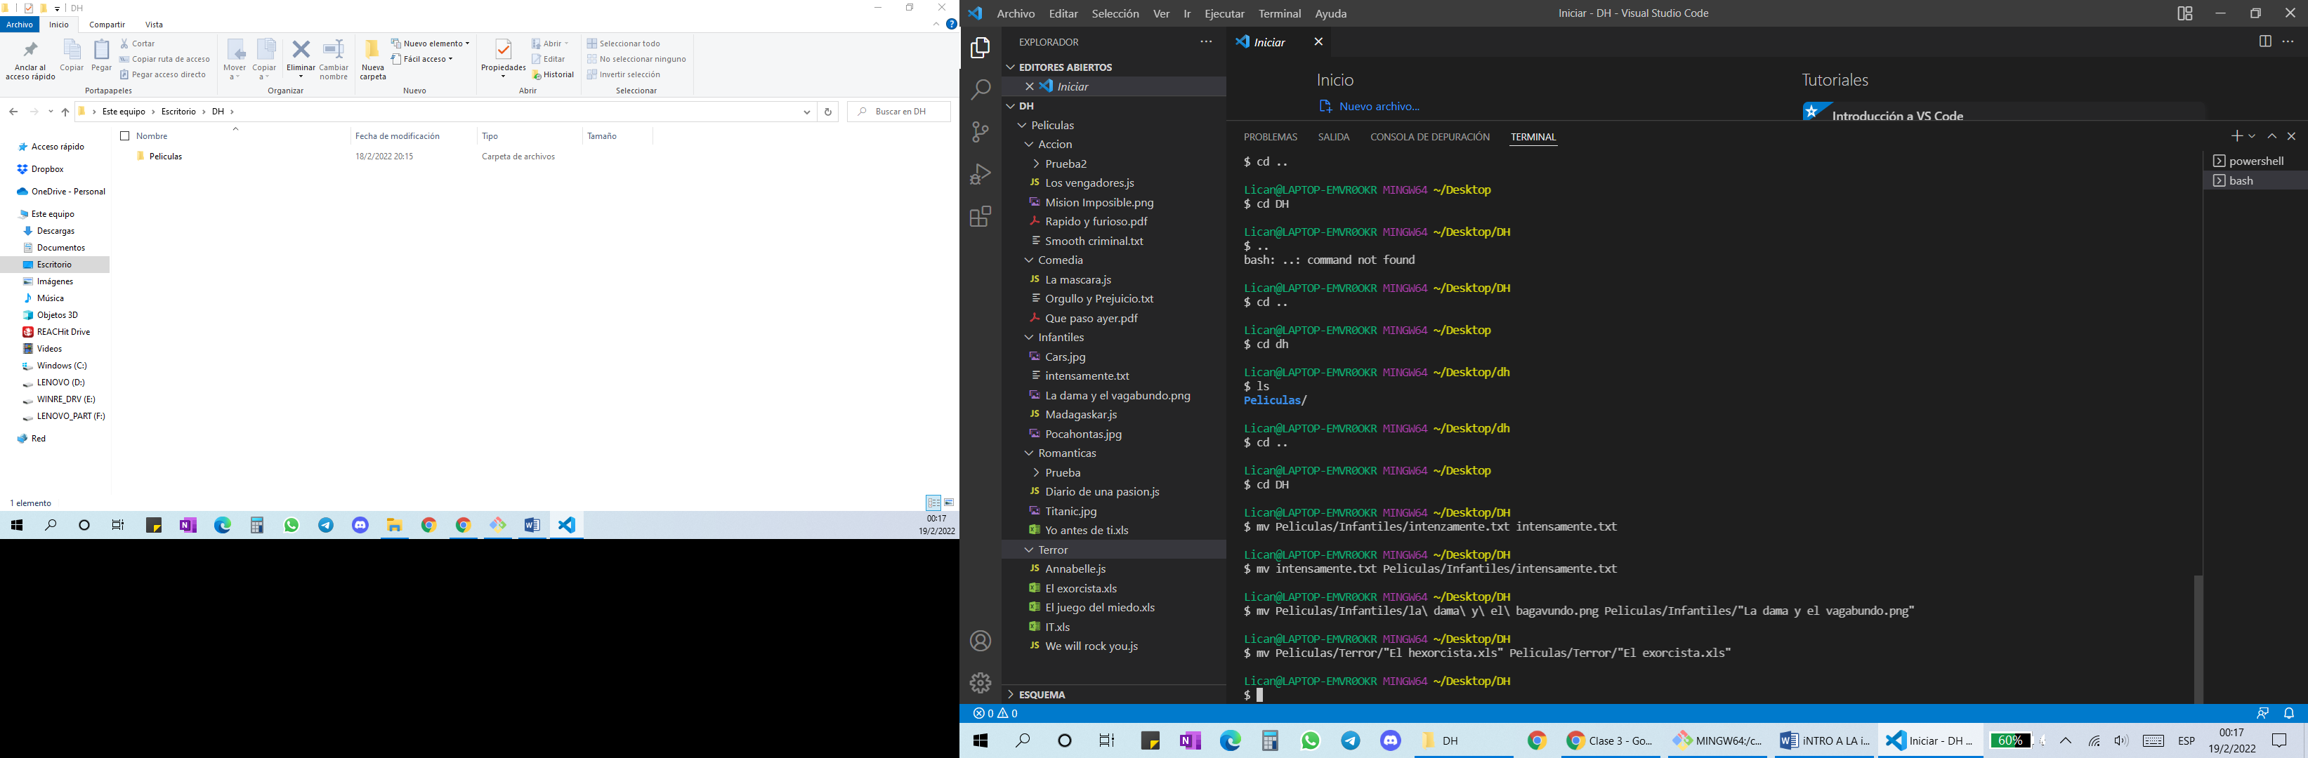

4)

Lican@LAPTOP-EMVR0OKR MINGW64 ~/Desktop/DH

$ rm Peliculas/Accion/Smooth\ criminal.txt Peliculas/Comedia/Orgullo\ y\ Prejuicio.txt Peliculas/Terror/We\ will\ rock\ you.js

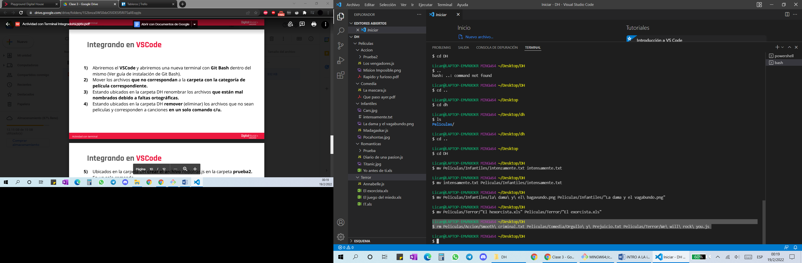

5)

Lican@LAPTOP-EMVR0OKR MINGW64 ~/Desktop/DH

$ touch Peliculas/Accion/Prueba2/noBorrar.js

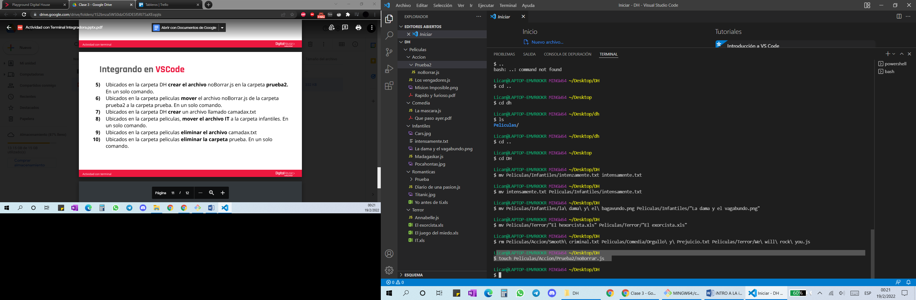

6)

Lican@LAPTOP-EMVR0OKR MINGW64 ~/Desktop/DH/Peliculas

$ mv Accion/Prueba2/noBorrar.js Romanticas/Prueba/

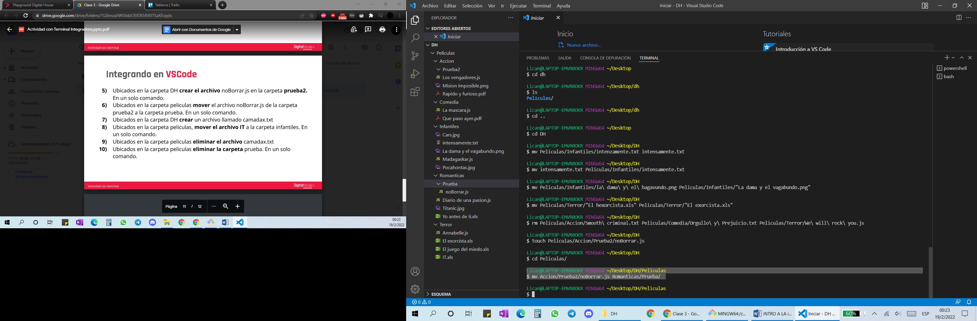

7) y 8)

Lican@LAPTOP-EMVR0OKR MINGW64 ~/Desktop/DH/Peliculas

$ cd ..

Lican@LAPTOP-EMVR0OKR MINGW64 ~/Desktop/DH

$ touch camadax.txt

Lican@LAPTOP-EMVR0OKR MINGW64 ~/Desktop/DH

$ cd Peliculas/

Lican@LAPTOP-EMVR0OKR MINGW64 ~/Desktop/DH/Peliculas

$ mv Terror/IT.xls Infantiles/

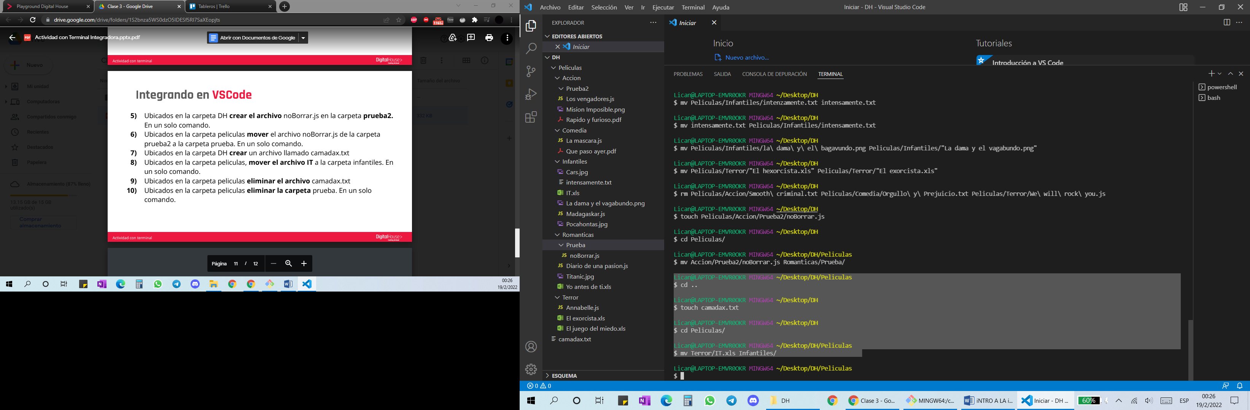

9)

Lican@LAPTOP-EMVR0OKR MINGW64 ~/Desktop/DH/Peliculas

$ rm ../camadax.txt

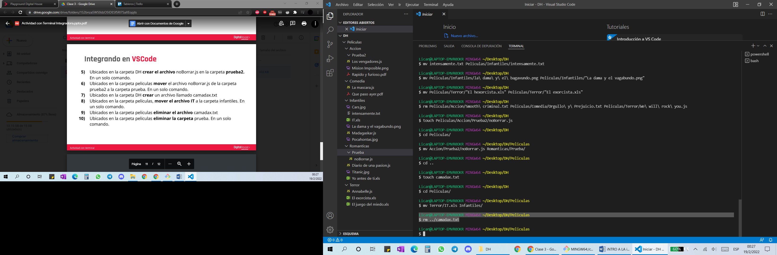

10)

Lican@LAPTOP-EMVR0OKR MINGW64 ~/Desktop/DH/Peliculas

$ rm -r Romanticas/Prueba/

